Test Documentation
Positive Scenarios - 1 http:/localhost:8080/api/v1/customers/CUST001/rewards?fromDate=2026-06-01&toDate=2026-08-31
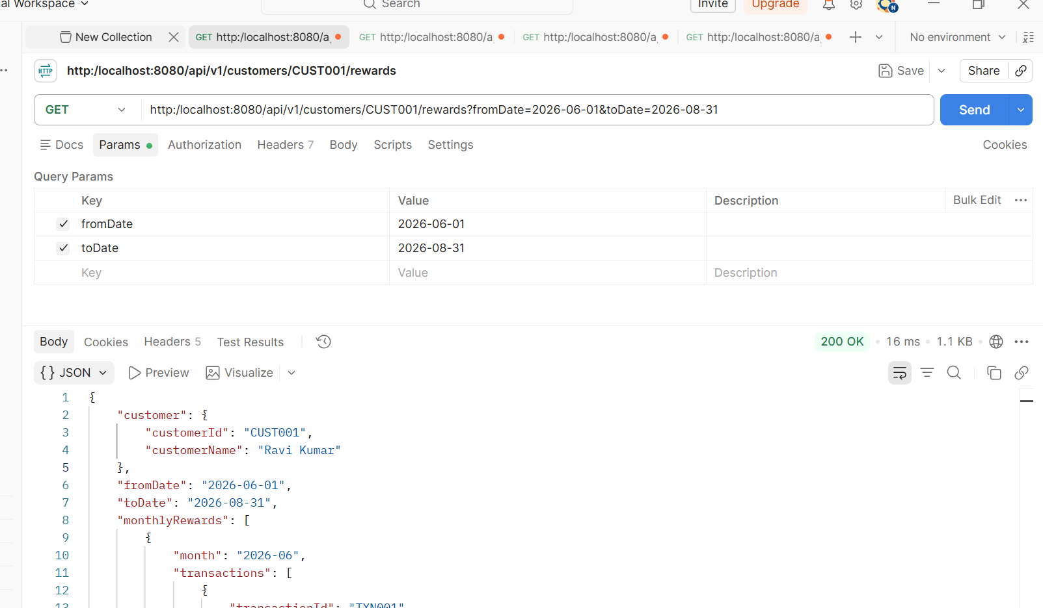

http:/localhost:8080/api/v1/customers/CUST001/rewards?fromDate=2026-01-01&toDate=2026-03-31
No transaction found for customer in that particular period of time.
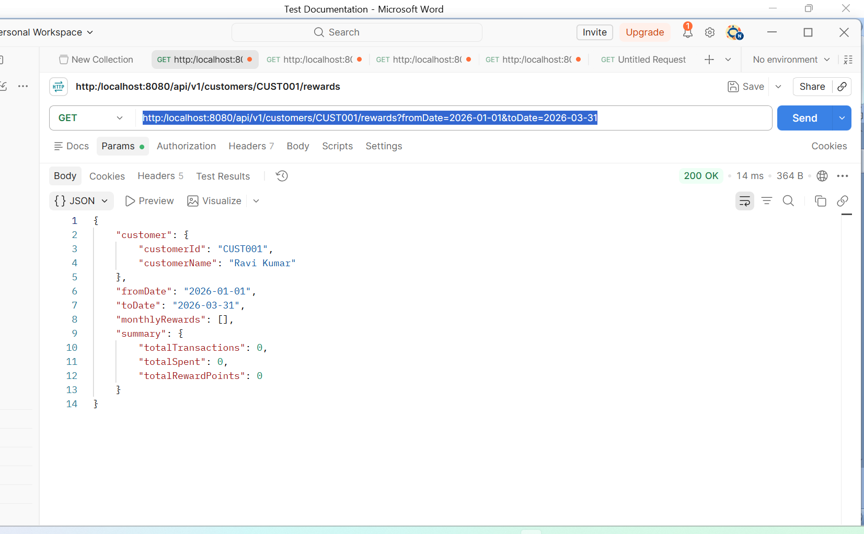

Positive Scenarios - 2
http:/localhost:8080/api/v1/customers/CUST001/rewards?fromDate=2026-06-01
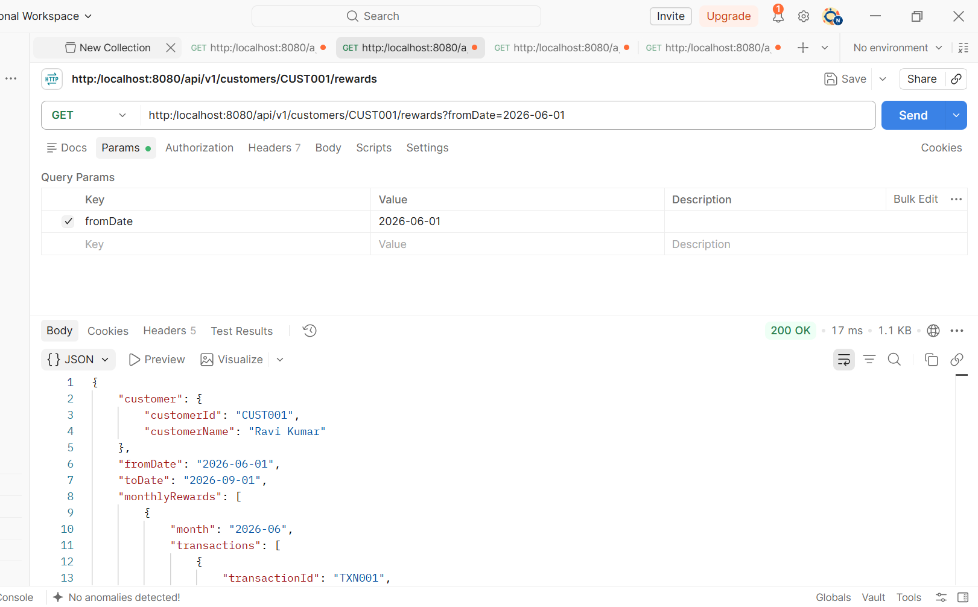

Positive Scenarios - 3
http:/localhost:8080/api/v1/customers/CUST001/rewards?toDate=2026-08-31
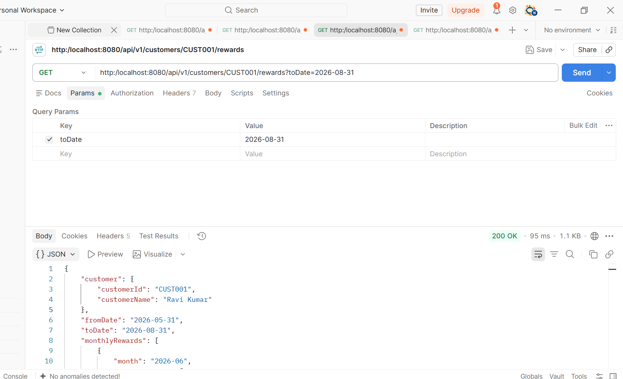

Positive Scenarios - 4
http:/localhost:8080/api/v1/customers/CUST001/rewards
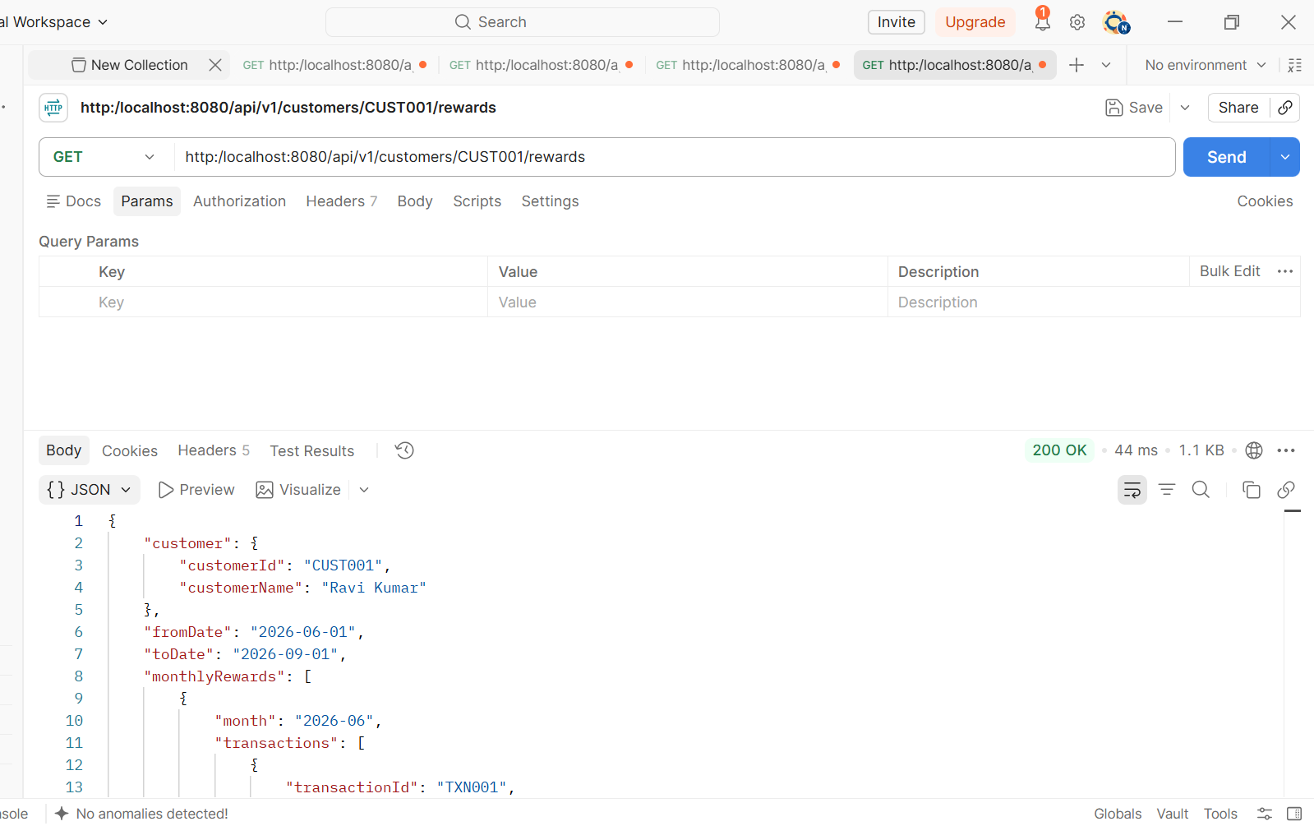

Negative Scenarios - 1
http:/localhost:8080/api/v1/customers/%20/rewards
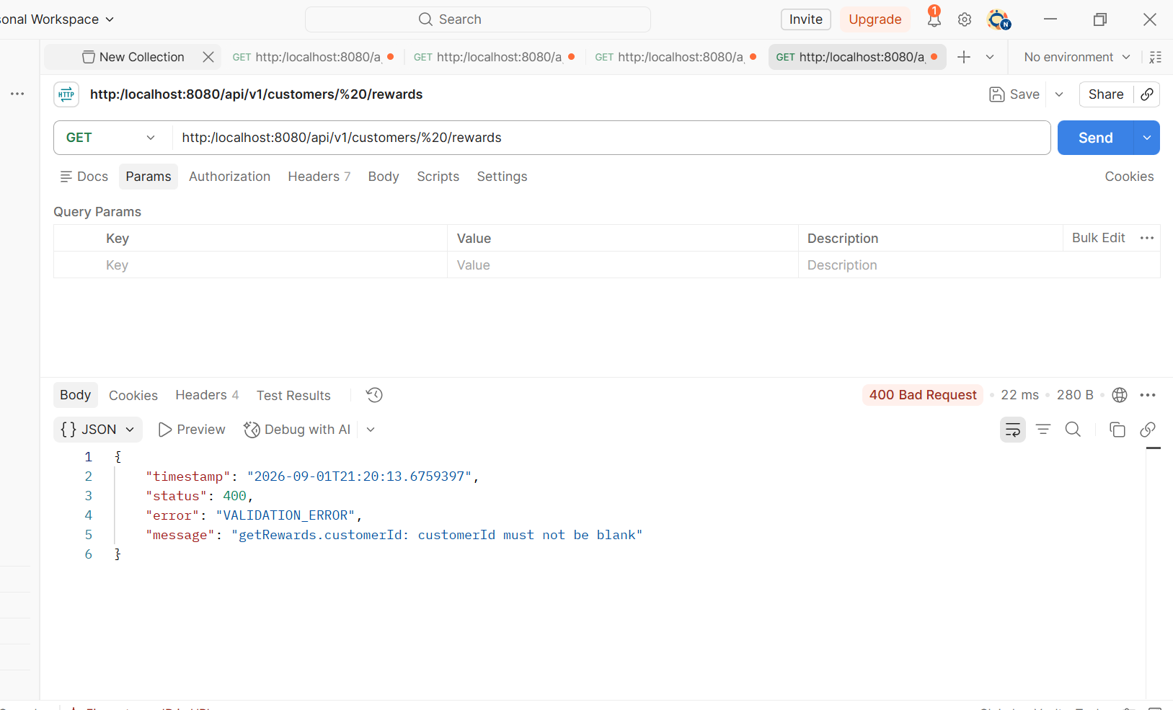

Negative Scenarios - 2
http:/localhost:8080/api/v1/customers/CUST005/rewards
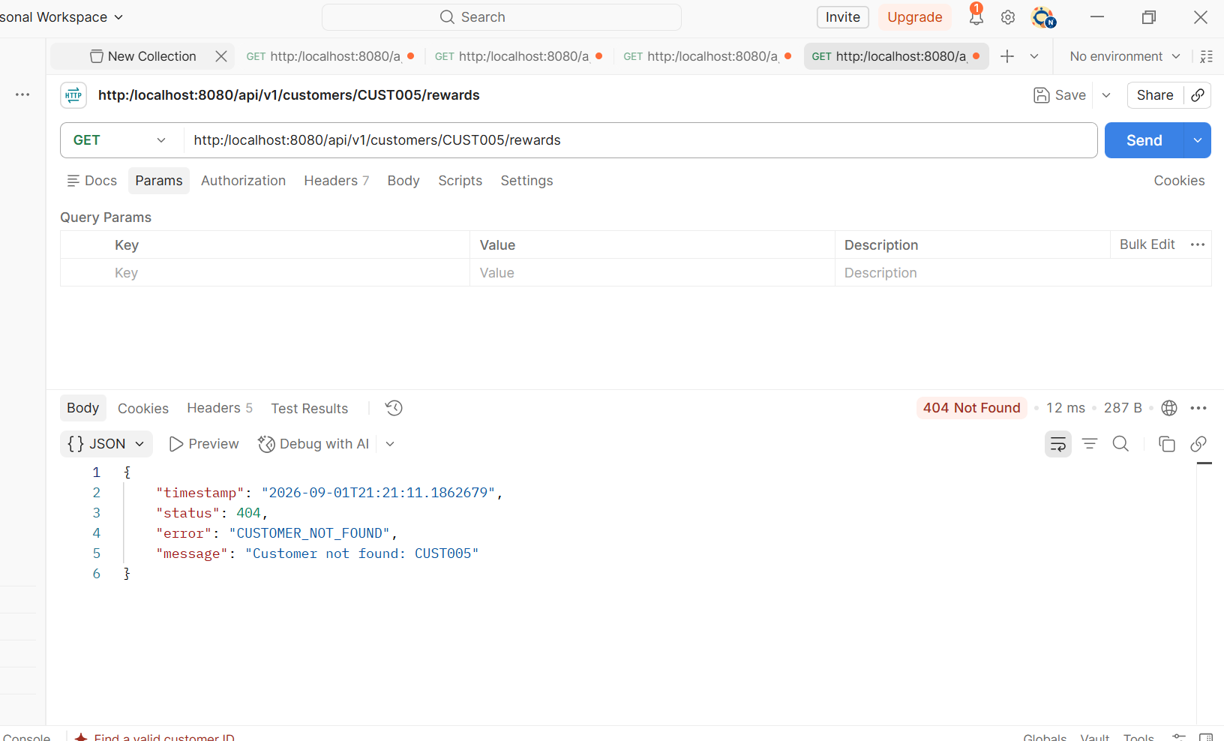

Negative scenario -3
